Accident Report Form

Date of incident |  |  | Time of incident
Venue

Injured person
Player | Match Official | Coach | Spectator | Other

Name |  |  | DOB
Address |  |  | Age
Postcode |  |  | Gender | Female | Male

Type of activity at time of injury
Training | Cool Down
Warm-up | Other please specify
Competition

Reason for presentation
New Injury | Illness
Aggravated injury | Other please specify
Recurrent injury

Body parts injured circle and name
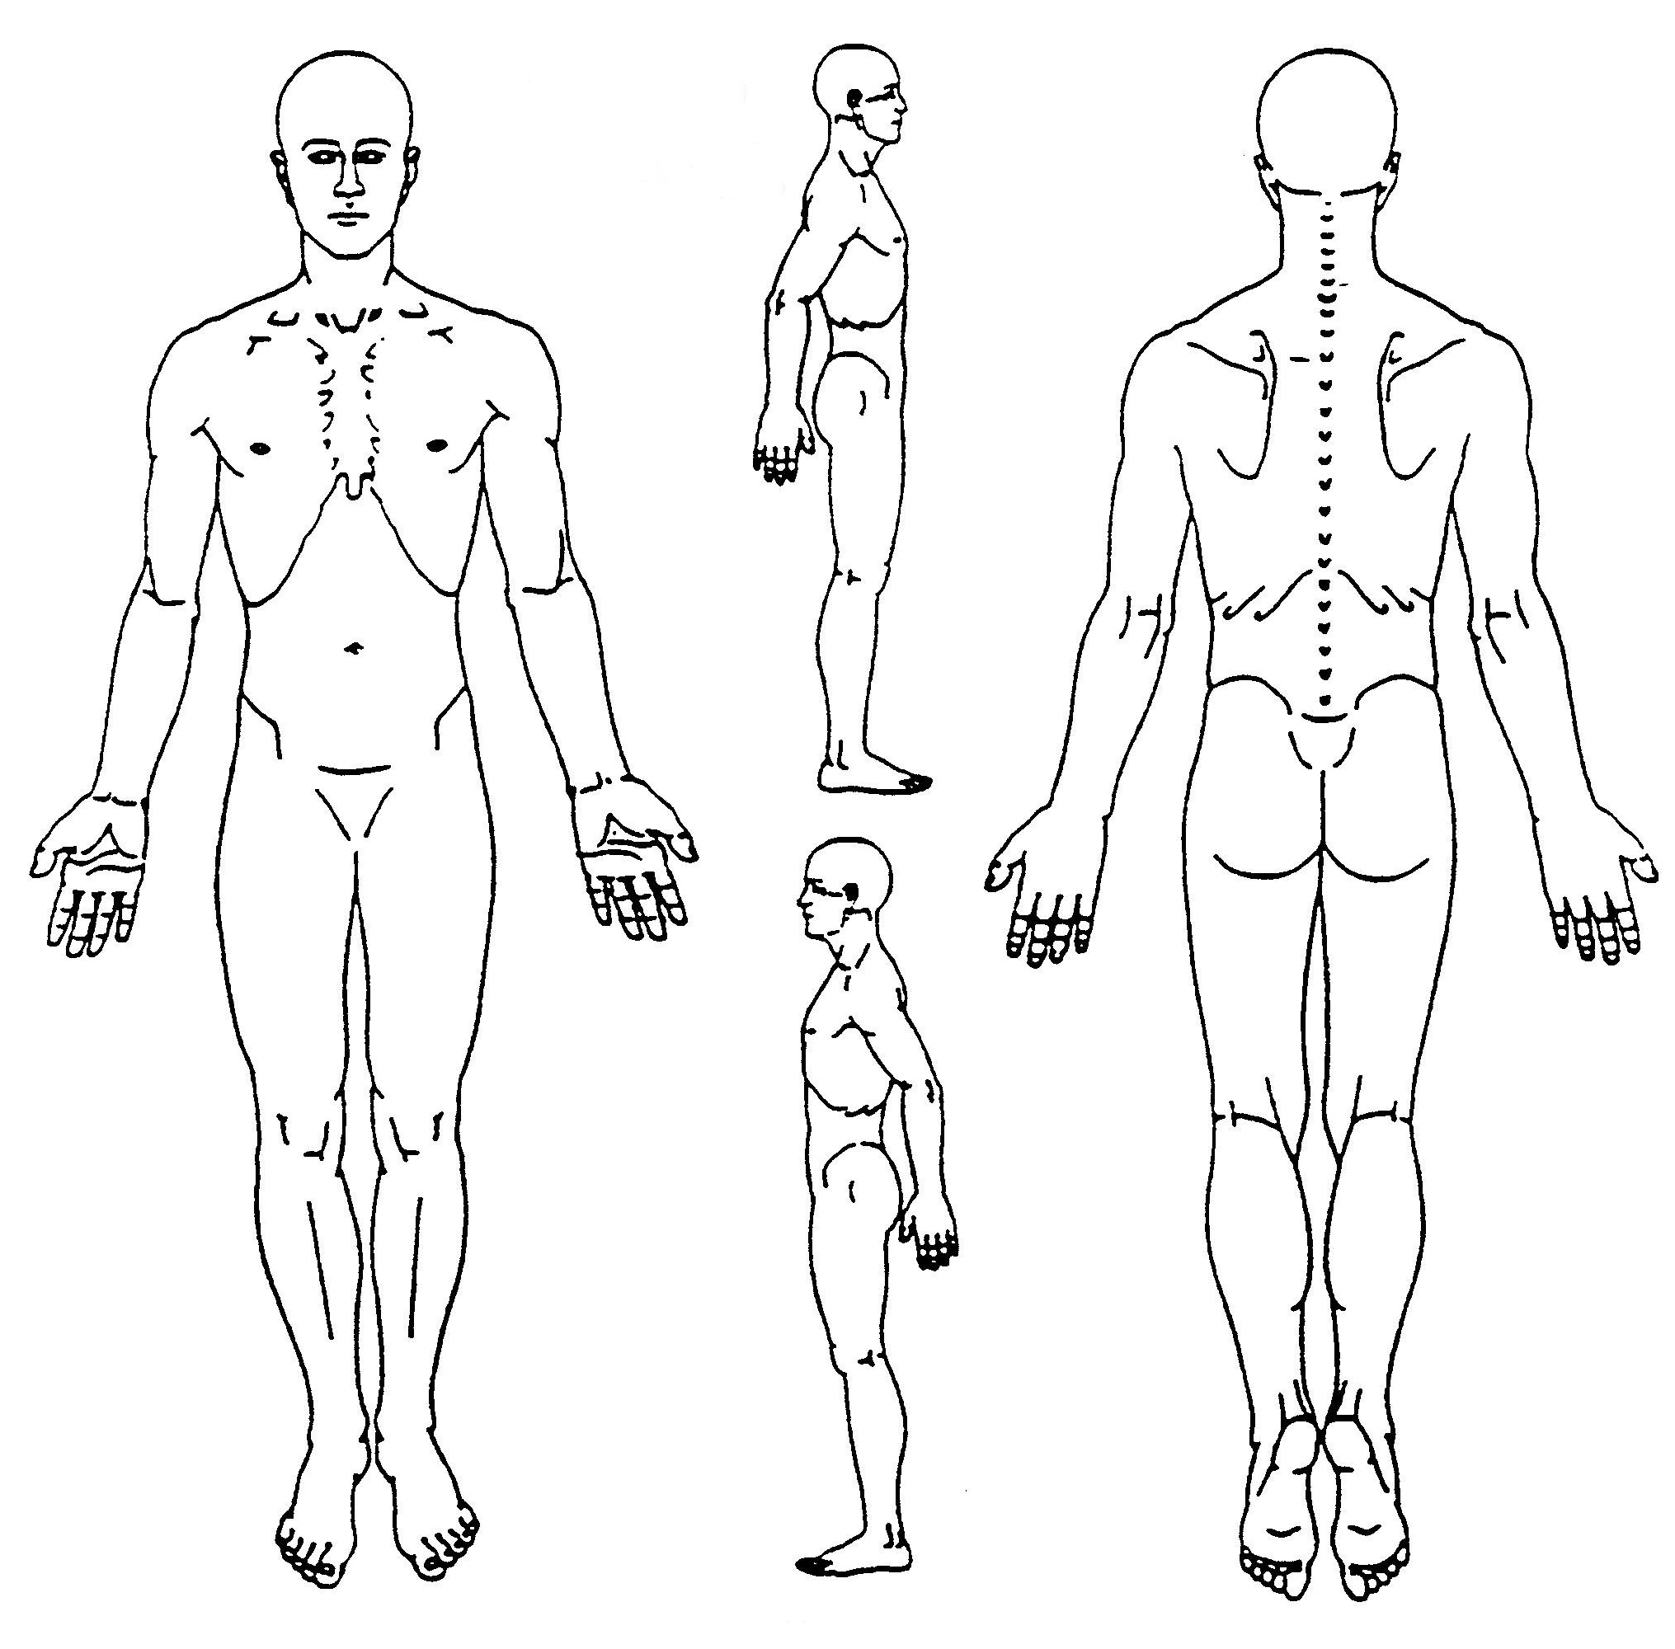

Nature of injury/illness
Bruise/contusion | Inflammation/swelling | Loss of consciousness
Skin injury e.g. cut, blisters | Fracture (including suspected) | Overuse injury
Sprain e.g. ligament tear | Dislocation/subluxation | Respiratory problem
Strain e.g. muscle tear | Concussion | Cardiac problem
Other please specify

Cause of injury
Collision with other player | Slip/trip/fall/stumble | Collision with fixed object
Fall from height | Overexertion | Struck by other player
Awkward landing | Struck by ball/object | Overuse
Jumping to shoot or defend
Other please specify

Explain how the incident occurred

Were there any contributing factors to the incident e.g. unsuitable footwear, playing surface, equipment, foul play etc

Initial treatment
None given (not required) | Immobilisation | Strapping/taping
CPR | Ice | Stretch/exercises
Dressing | Sling/splint | Transport from field/court
Other please specify

Advice given
Immediate return to activity
Return to play with restriction
Unable to return at present
Referred for further assessment before returning to activity

Notice | Tick | Initial
The injured person was advised that if injury/illness does NOT improve in the following 24-hours they MUST seek further advice from their own medical professional

Provisional severity assessment
Mild (1-7 days modified activity)
Moderate (8-21 days modified activity)
Severe (>21 days modified or lost)

Referral
No referral | Ambulance
Medical practitioner | Hospital
Physiotherapist
Other please specify

All of the above facts are a true and accurate record of the accident;
 | Injured party |  | Parent/Guardian  (if aged under 18-yrs) |  | Treating person
Name
Signature

